**Development for SHOP+**

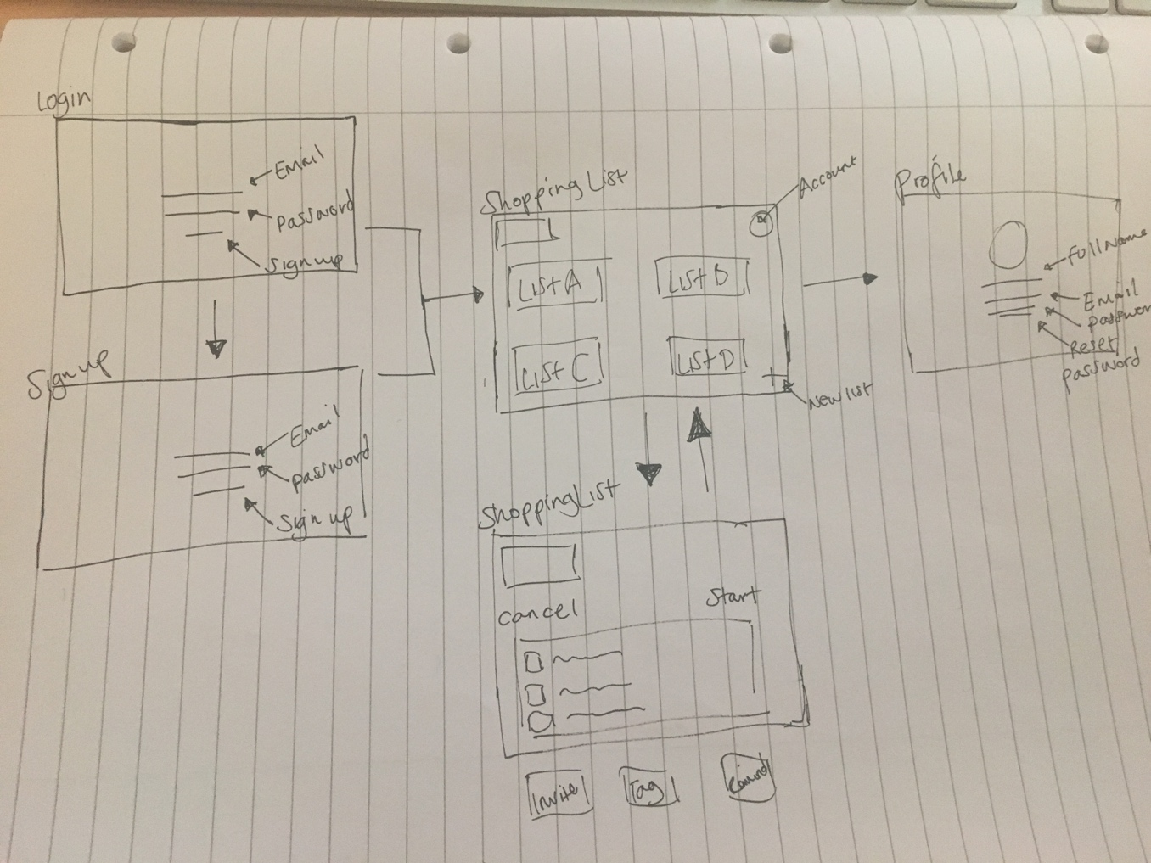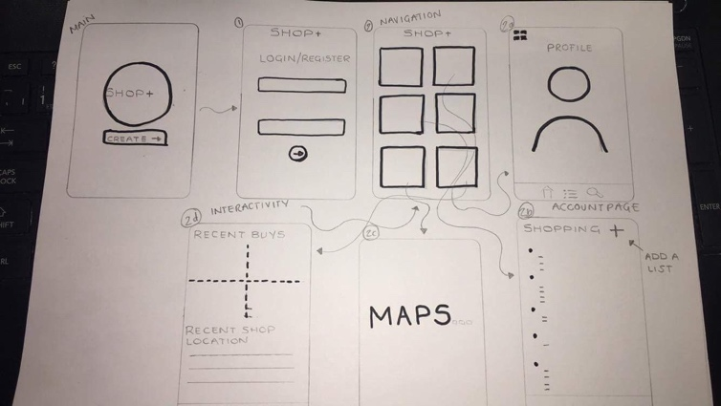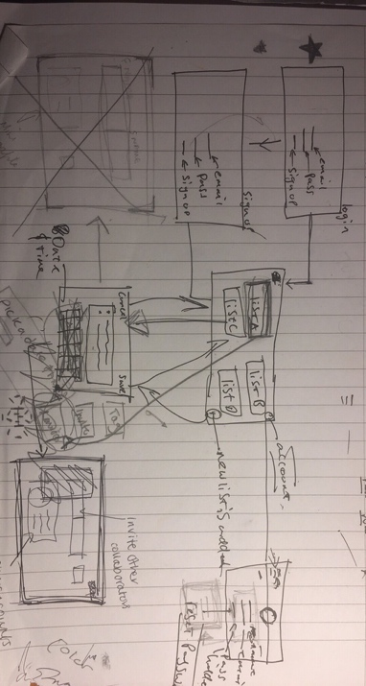**Development idea:** After group discussions, we decided to make a few changes to the concept of the app because of the way would need to function. After a talk with Chris about the Google Maps API we realised we would need to find another way around this because it wouldn’t have been very useful on a desktop to track your position. This changed the idea from a user being able to receive a notification to having to manually set up the date and time of when they would want the shopping list to be sent to them. We agreed to take-away the calendar element so the user would be able to see on web page the different days they have a shopping list. The images below show the development of our site map and how we have changed the functions within the app.

**What went well:**

* The navigation for the app, making it easier for the user to understand how it works.
* Following up the initial idea to make final wireframes in illustrator.
* Being able to identify how we would link it all together with the code needed.
* Identifying what technologies, we would need to use. (MongoDB, Express. Angular)

**What didn’t go well:**

* The idea of using Google Maps API
* The idea of having a calendar displayed